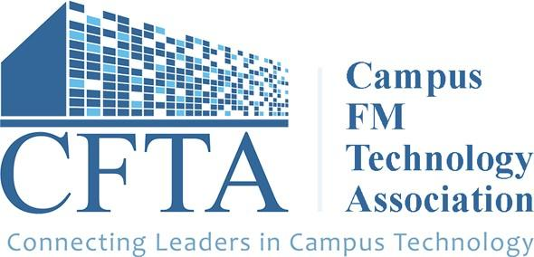
Dear [Manager/Supervisor’s Name]:

The 2024 Campus FM Technology Association (CFTA) Conference is July 30 - August 1, 2024, in Pasadena, California. This event will feature two to three days of educational sessions and presentations from industry leading facilities management professionals, round-table discussions on critical issues affecting the deployment and maintenance of campus FM technologies and systems, and optional campus tour of California Institute of Technology, our local member host. I am writing to request approval to attend the 2024 CFTA Conference, as I believe doing so will further develop my technical skills while building knowledge around new campus FM technology innovations and shared best practices.

In attending this conference, I will receive:

- One half day of pre-conference technical sessions on the latest FM technologies and trends led by world leaders in FM technologies.

- Inspiring main stage sessions and interactive programming along with breakout sessions led by universities and facilities management solution innovators. Topics include asset management, BIM, CAD, digital twins, document management, drones, GIS, integrated workplace management systems, national standards, new technologies, space information and management, system/data integration, utilities, and more.

- Approximately 7 hours of networking (excluding meals and breaks). Dedicated networking time in a fun collaborative environment promotes developing relationships and building contacts for future collaborations. Network while you participate in an optional campus tour of California Institute of Technology in Pasadena and make lasting memories attending Thursday night's CFTA Special Event.

- The chance to stay in the know of the latest campus FM technology trends from industry leaders as well as learn ﬁrsthand about actual end-user experiences from seasoned practitioners.

You can learn more about the conference here: https://www.cfta.org/conference

A large majority of my meals are included with the cost of registration and I have included estimated travel costs to attend and enhance my professional development by bringing new knowledge and best practice back to our campus.
Cost Estimate
Travel costs $XXX
Accommodation (2 to 3 nights at $199/night)* $400.00 to $600.00
Meals (2 to 3 days at $XXX)** $XXX
Registration (for 2 days + pre-conference
session) ^{$1,200 - $1,300}

Ground Transportation (rideshare/taxi ~$100 - $200) $75 - $200
Total cost to attend: $X,XXX

*Hotel costs do not include applicable taxes. This is a conference block negotiated hotel rate.
**Two breakfasts/am breaks, two lunches, one reception and one dinner reception provided. (Tuesday - Thursday)
***Registration rates vary by pre-conference participation, regular and late registration options.

I hope you agree that the CFTA Conference is a good investment of time and resources that will beneﬁt our department and institution as a whole. Thank you for considering this request.

[your name here]

